Topics:
- Data Science Processes:
  - CRISP-DM
  - OSEMN
  - TDSP
  - KDD
- Data Science Ecosystem
Data Science Process:
- Reason: Companies put forward suggestions on what is best process to climb data-science pyramid.
- CRISP-DM (Cross Industry Standard Process for Data Mining):
- It is widely used and applicable across all industries.
- Presented first in 1999 in a workshop.
Lifecycle:
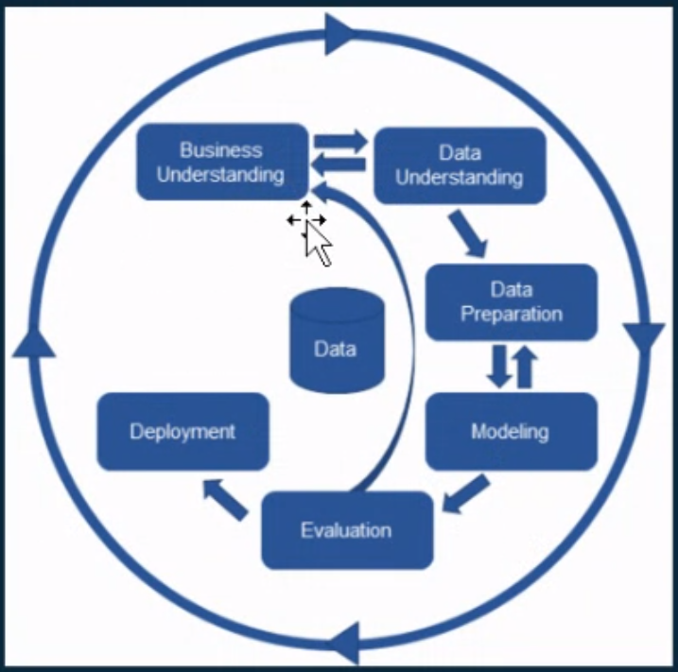

Stages:
- Business understanding: Requirement Analysis.
- Data understanding: Gather data available in the business from stack holders and non-technical people such as sales, operations, and maybe some technical people such as DBA.
- Data preparation: Create (unified) dataset that can be used for data analysis from multiple data sources and data warehouses. Check quality of data and must fix it. Basically, perform data analysis.
- Modeling: Extract patterns from data and create a model that learns from the training set by using several algorithms to train various models on the dataset and check the performance.
- Evaluation: Filter the models as per the expectations in the context of business understanding based on data and algorithm.
- Deployment: Once selected models are ready, it is necessary to understand how to fit the individual models in the system.
- OSEMN (Obtain, Scrub, Explore, Model, and iNterpret) framework:
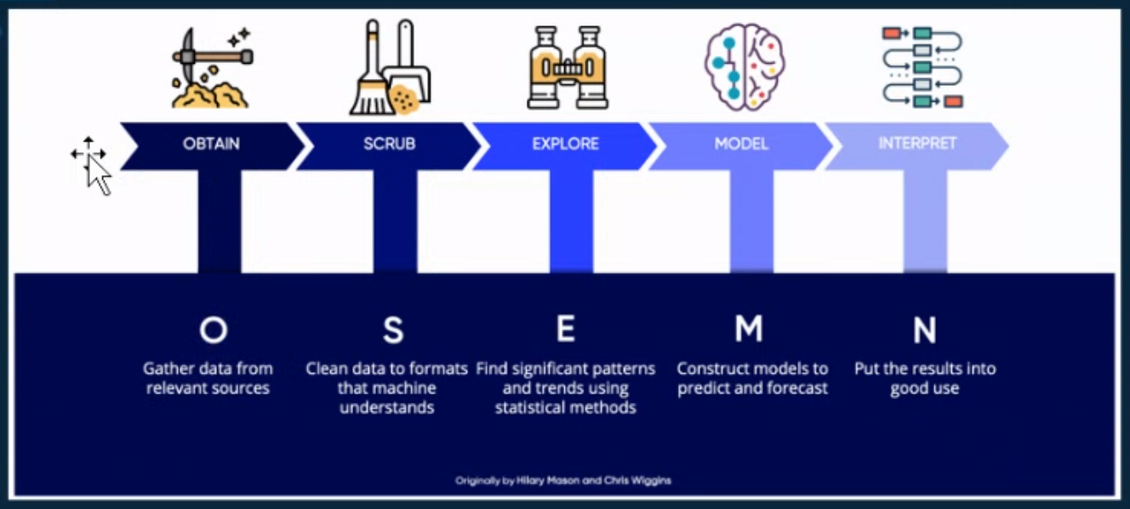
- TDSP (Team Data Science Process):
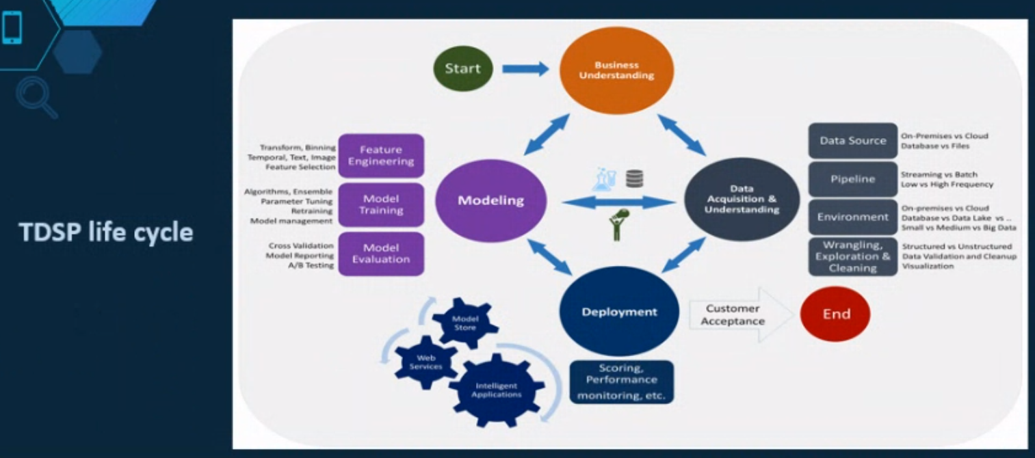
- Developed and used by Microsoft.
- Keeps a track and artifacts in a report of individual stages.
- Microsoft provides such templates for such documents, standards, and for any steps carried out for this cycle.
- In each stage, a check-list provider is there to determine whether the requirements are fulfilled in a specific stage.
- KDD (Knowledge Discover and Database):
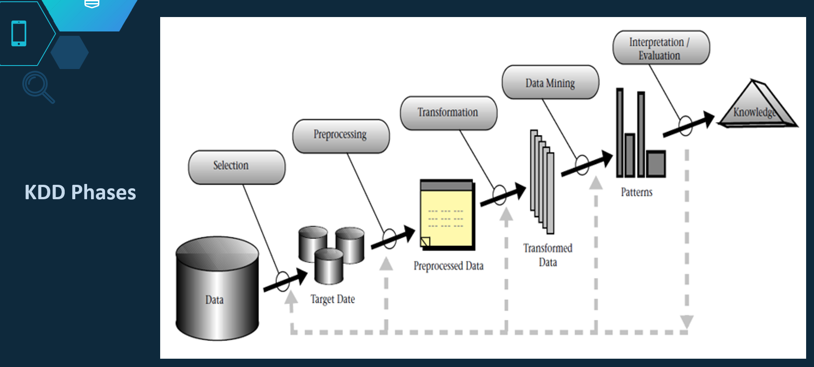
Data Science Ecosystem:
- A collection of infrastructure, analytics, and applications used to capture and analyze data.
- Applications: End users who interact with the application created.
Architecture:
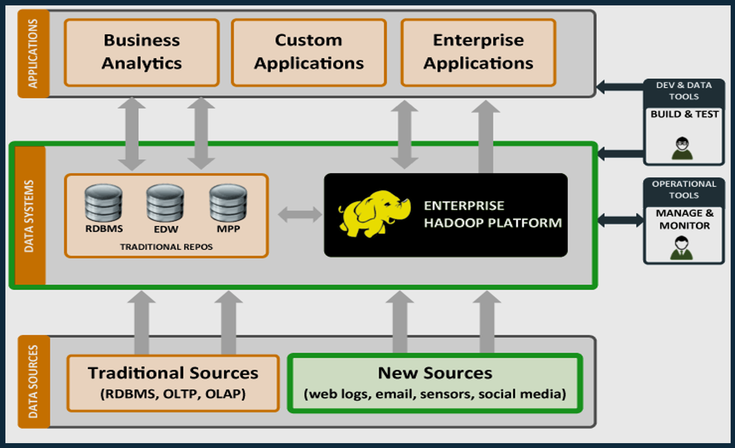
- Data Sources:
- Forms initial dataset for machine learning data algorithm.
- OLTPs (OnLine Transactions Processing) are used.
- Data starts capturing once the system becomes big scale.
- New sources such as web data, sensors, and social media, which can be added once the organization wants more diversity.
- Data Systems:
- Relational databases are initially used.
- Enterprise Data Warehouse is used when the data becomes unhandled for relational structures.
- MPP is used when the data comes under the category of big data.
- Used for analytical processing.
- Hadoop is an open-source framework by Apache.
- Hadoop is used for storage and analytics of big data.
- Hadoop is used for distributed storage and distributed processing across clusters of servers applying map-reduce programming technique.
- Hadoop uses the Split-Apply-Combine strategy.
- Queries are split in various clusters (especially chunks), a query has been applied on each chunk, and combines each chunk’s results once performed.
- Usually preferred when the data size exceeds and calculated in petabytes.
- Applications:
- Various applications that are used by the user/customer.
- The actual source of data generated.
- All the services and applications that act upon the data and make it usable.

